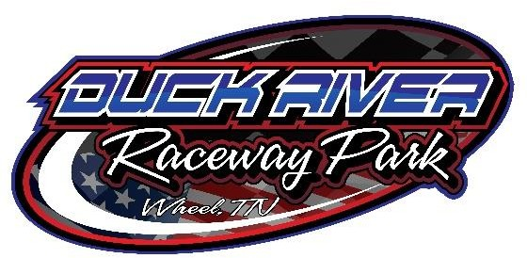

2023 CODE OF CONDUCT
- Any driver, car owner, mechanic or crew member who encourages or participates in adverse demonstrations, or fights on the track property or surrounding premises before, during or after a race event, shall be subject to a fine, immediate suspension, loss of prize money and championship points. Minimum fine will be $250
- Any driver, car owner, mechanic or crew member who shall commit assault or threaten to do bodily harm to speedway officials, or persons under speedway official’s orders, shall be barred from competition at the speedway and subject to prosecution
- If, in the judgement of speedway officials, there is necessary roughness on the track, the race will be stopped, and the person involved will be put in the pits
- The conduct of an owner, driver, mechanic or crew member that is considered unsportsmanlike in the continuance of an event, shall be subject to a fine, suspension and barred from further competition at the speedway
- The driver ALONE will be held responsible for the conduct of their crew members. The driver ALONE shall be the sole spokesman for their car in any matter pertaining to the race and must talk to the officials in charge
- Any driver, car owner, mechanic or crew member who verbally abuses or ridicules any speedway official or persons under speedway official’s orders, shall be subject to a fine, immediate suspension and loss of prize money and championship points
- Any driver, car owner, mechanic or crew member who climbs on the flag stand, without being instructed to do so, will be fined $100 and subject to being barred
- Any fines or suspensions must be settled with speedway officials before a driver, car owner or crew member will be allowed to participate in another event at the speedway
- The management reserves the right to refuse entry to any car or person without question
- All drivers must have a signed social media policy on file

