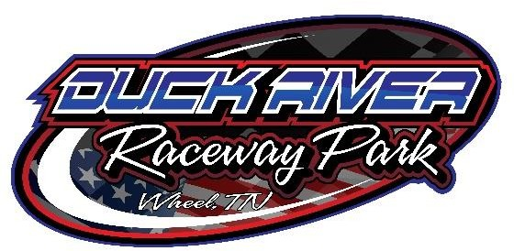
2023 ENDURO

MANDATORY: All driver’s and cars MUST HAVE Raceceivers and Transponders
Rules:
- No Race Cars
- Any 1965 or newer car, NO SUV’S
- No special-order vehicles. No turbos or supercharged cars, must be normally aspirated,
- Must have good working brakes and be safe to drive!
- NO MUSTANGS OR CAMAROS!
- Must have factory suspension, no alterations
- No after-market parts
- No racing shocks
- Stock motor and transmission only, no high-performance parts, headers, carburetors or high-rise intakes
- Must run factory carburetor for that car
- Cars with factory headers will be permitted
- No bars may pass thru fire wall to front of vehicle and may not pass thru rear speaker deck
- No radiator support reinforcement
- Straight shifts are legal only if car came from the factory with it
- No locked or posi traction rear-ends. Limited slip permitted
- Tires and wheels stock for make and model
- All glass must be removed
- Windshield must be removed, and 3 bars placed in front of driver for debris protection and passenger. $25 fee for passenger to ride
- Headlights, taillights and all trim must be removed, including hubcaps
- Cars must have visible numbers on each side and on roof
- All doors must be chained or welded shut
- No two-way radios
- Remove all bumper covers
- You CAN move the battery in the car if you feel it is warranted
- Pill draw for starting position
- Upon visual inspection of cars, if they don’t appear to be stock from the factory (parts or modifications), we will return your entry fee and you will not be allowed in the event

Buy Rule:
- THERE WILL BE A $3000 buy rule for any car! If you fail to sell your car, you will lose all pay for that event and not be allowed to attend anymore Enduro races for a calendar year
- THERE WILL BE A $500 buy rule for carburetor
- THERE WILL BE A $250 buy rule for computer
Safety:
- Helmet with shield or goggles, long pants and long sleeve shirt
- Fire suit is strongly recommended but not required
- Fire extinguisher is MANDATORY and should be secured
- Roll cage is strongly recommended but not required
- Must have working seatbelt. 5-point harness strongly recommended
- MUST BE 16 YEARS OLD & HAVE A VALID ID IN ORDER TO PARTICIPATE

This is not a demolition derby
If you are caught racing dirty, you will be black flagged

